1.

Write 0.01723 in standard form.
A.
0.01723 x 10⁻²
B.
0.01723 x 10²
C.
1.723 x 10⁻²
D.
1.723 x 10²

2.

What is the value of 3x² + 2x - 7 when x = -3?
A.
-40
B.
-33
C.
14
D.
26

3.

Find the image of the point S(-2,2) when it is reflected in the y-axis.
A.
(2,-2)
B.
(2,2)
C.
(-2,-2)
D.
(-2,2)

4.

What is the actual bearing of S25ºE?
A.
035º
B.
065º
C.
115º
D.
155º

5.

Given that m =
b
2
- t, make t the subject.
A.
t =
b - 2m
2
B.
t =
2m - b
2
C.
t =
2b - m
2
D.
t =
b + 2m
2

6.

Expand (x - 2)(x + 4).
A.
x² + 2x - 8
B.
x² + 2x + 8
C.
x² - 4x - 8
D.
x² - x - 8

7.

If n(E) = 15, n(F) = 20 and n(E∩F) = 6, find n(E∪F).
A.
21
B.
26
C.
29
D.
35

8.

Tony shared
2
3
of his plot of land equally among his three sons. What fraction of the plot did each get?
A.
2
9
B.
1
3
C.
1
2
D.
5
9

9.

Araba and Ama share 20 oranges in such a way that Ama receives 12 oranges. Find the ratio of Araba's share to that of Ama.
A.
2:5
B.
3:5
C.
3:2
D.
2:3

10.

Solve: 3(x - 2) -
x
3
+ 6 > 0.
A.
x < 0
B.
x > 0
C.
x > 3
D.
x >
1
8

11.

The stem and leaf plot shows the marks scored by students in a French test. Use the information to answer the question below.
Stem | Leaf
2 | 0 2 5 7 8
3 | 2 7 9
4 | 3 5 5 5
5 | 4 6 6 8
6 | 3 5 7
7 | 0 6
What is the modal mark?
A.
35
B.
45
C.
56
D.
76

12.

The stem and leaf plot shows the marks scored by students in a French test. Use the information to answer the question below.
Stem | Leaf
2 | 0 2 5 7 8
3 | 2 7 9
4 | 3 5 5 5
5 | 4 6 6 8
6 | 3 5 7
7 | 0 6
How many students took the test?
A.
20
B.
21
C.
22
D.
27

13.

The stem and leaf plot shows the marks scored by students in a French test. Use the information to answer the question below.
Stem | Leaf
2 | 0 2 5 7 8
3 | 2 7 9
4 | 3 5 5 5
5 | 4 6 6 8
6 | 3 5 7
7 | 0 6
Find the median mark.
A.
45
B.
47
C.
54
D.
76

14.

Which of the following is an even prime number?
A.
2
B.
1
C.
4
D.
8

15.

If 2n - 5 =
1
2
n, find the value of n.
A.
1
3
B.
1
2
C.
2
1
2
D.
3
1
3

16.

Find the simple interest on GH₵ 350.00 for 4 years at 5% per annum.
A.
GH₵ 20.00
B.
GH₵ 35.00
C.
GH₵ 70.00
D.
GH₵ 140.00

17.

A straight line passes through the points P(-5,-3) and Q(-4,-7). Find the gradient of the line PQ.
A.
-4
B.
-
1
4
C.
1
4
D.
4

18.

Given that 1 kilometre =
5
8
mile, what is 240 miles in kilometres?
A.
150 km
B.
190 km
C.
384 km
D.
390 km

19.

John walks for 22
1
2
minutes and runs 7
1
2
minutes to school. What percentage of the total time does he spend walking?
A.
25%
B.
30%
C.
33%
D.
75%

20.

Kobby is 5 years older than his brother. If Kobby is 13 years old, how old is his brother?
A.
7 years
B.
8 years
C.
10 years
D.
18 years

21.

Find the rule for the mapping:
x | 1 | 2 | 3 | 4 | 5
↓ | ↓ | ↓ | ↓ | ↓ | ↓
y | 4 | 2 | 0 | -2 | -4
A.
y = 2x + 2
B.
y = -2x + 2
C.
y = 4x
D.
y = -2x + 6

22.

Arrange the following numbers in ascending order:
9
5
,1.88,
15
8
A.
9
5
,
15
8
,1.88
B.
15
8
,1.88,
9
5
C.
1.88,
9
5
,
15
8
D.
9
5
,1.88,
15
8

23.

Simplify: (x - 1)² - 1.
A.
x² - 2x
B.
x² + 2x
C.
x² - 2x - 1
D.
x² - 2x + 1

24.

A bag contains 20 oranges of which 6 are bad. Find the probability of picking a good orange from the bag.
A.
1
20
B.
3
10
C.
1
6
D.
7
10

25.

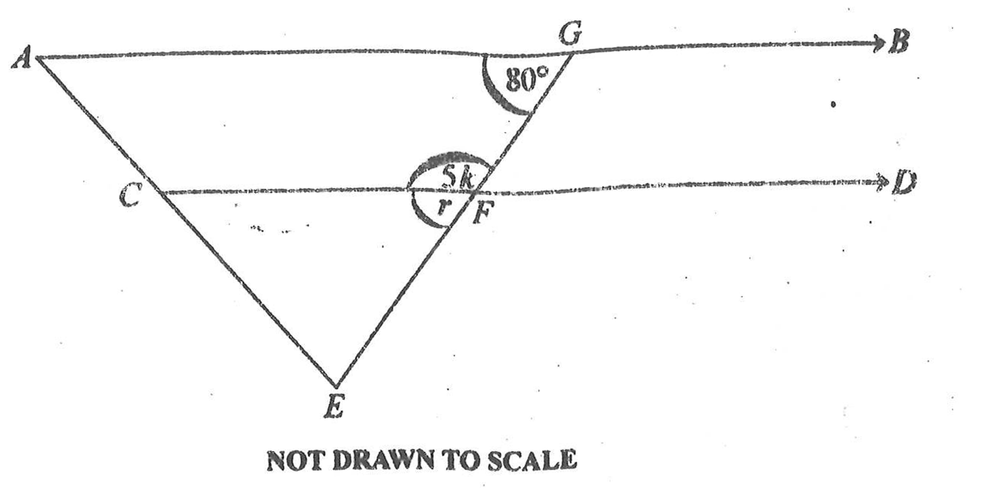
In the diagram, AB is parallel to CD, Angle AGE is 80º, angle CFG = 5k and angle CFE = r.
Use the information to answer the question below.
What is the value of r?
A.
16º
B.
20º
C.
80º
D.
160º

26.

In the diagram, AB is parallel to CD, Angle AGE is 80º, angle CFG = 5k and angle CFE = r.
Use the information to answer the question below.
Find the value of k
A.
16º
B.
20º
C.
80º
D.
160º

27.

Simplify:
(
1
1
2
-
5
6

)
x
9
10
.
A.
1
10
B.
3
20
C.
1
5
D.
3
5

28.

Factorize 2pq + 6p -6q - 18.
A.
2(p - 3)(q - 3)
B.
2(p + 3)(q + 3)
C.
2(p - 3)(q + 3)
D.
2(p + 3)(q - 3)

29.

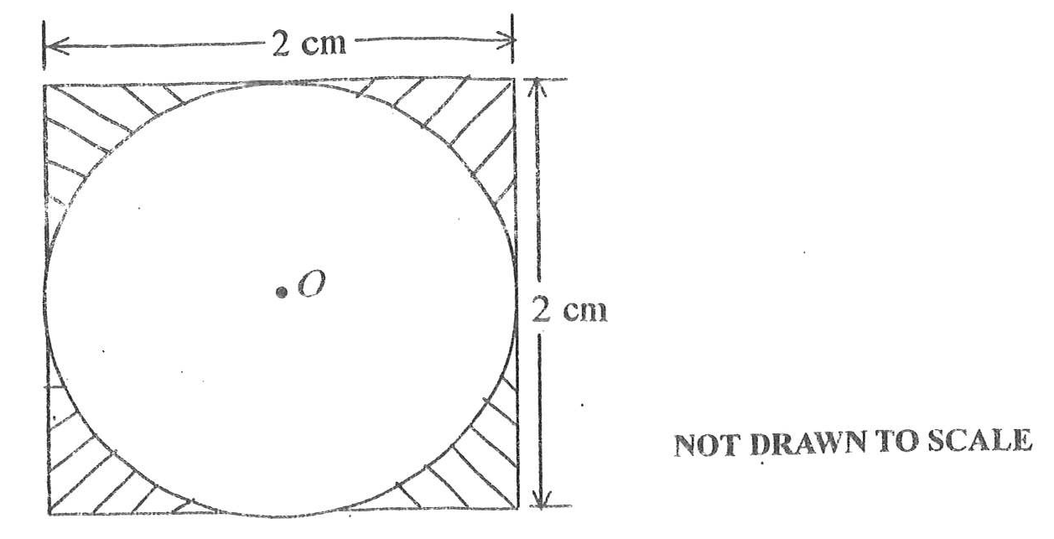
The diagram is a square of side 2 cm in which is inscribed a circle with center O.
Use the information to answer the question below.
Find the area of the shaded portion.
[Take π =
22
7
]
A.
0.86 cm²
B.
3.00 cm²
C.
6.28 cm²
D.
12.56 cm²

30.

The diagram is a square of side 2 cm in which is inscribed a circle with center O.
Use the information to answer the question below.
Find the area of the circle.
[Take π =
22
7
]
A.
3.14 cm²
B.
6.28 cm²
C.
4.00 cm²
D.
12.56 cm²

31.

A man can take 12 hours to do a piece of work. How long will it take 6 men working at the same rate to do the work?
A.
6 hours
B.
3 hours
C.
2 hours
D.
72 hours

32.

Convert 12.03 metres to centimetres.
A.
0.1203 cm
B.
120.3
C.
1203 cm
D.
12030 cm

33.

A quadrilateral with one pair of opposite sides parallel is called
A.
kite.
B.
rectangle.
C.
square.
D.
trapezium.

34.

A book was sold for GH₵ 48.00 at a profit of 20%. Find the cost price.
A.
GH₵ 38.40
B.
GH₵ 40.00
C.
GH₵ 60.00
D.
GH₵ 57.00

35.

Find the vector which translate the point (2,6) to (5,4).
A.
(
-3
2
)
B.
(
-1
4
)
C.
(
3
-2
)
D.
(
7
10
)

36.

Cement and sand were mixed in the ratio 2:5. How many kilograms of cement was contained in the 35 kg of the mixture?
A.
7 kg
B.
10 kg
C.
14 kg
D.
88 kg

37.

Which of the following is not an integer?
A.
0
B.
1
C.
0.5
D.
-5

38.

Simplify:
5
7
x
5
-4
5
3
.
A.
0
B.
1
C.
5
D.
25

39.

The height of a cylinder is 5 cm and the radius 7 cm. Find the volume of the cylinder.
[Take π =
22
7
]
A.
770 cm³
B.
700 cm³
C.
154 cm³
D.
110 cm³

40.

If q =
(
-2
3
)
and r =
(
3
-2
)
, find q - r.
A.
(
-5
5
)
B.
(
5
5
)
C.
(
-1
1
)
D.
(
1
1
)

